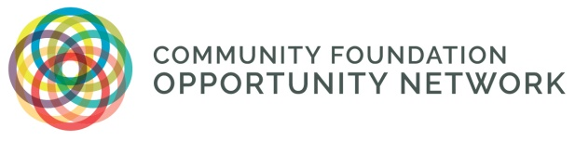

The Community Foundation Opportunity Network
Strategy Action Labs
taking your strategy to the next level

The Community Foundation Opportunity Network (CFON), established in early 2016, is a national leadership and action network of about 50 community foundations working to close opportunity gaps in our communities and increase social and economic equity. CFON members represent communities large and small, rural and urban, with a range of racial, ethnic, and socioeconomic diversity.
One element of CFON’s work is to provide participating foundations the chance to work together with others to critically assess and refine robust, scalable strategies that will make an impact in closing the gap. We do this by engaging small cohorts of community foundations working on common strategies and tackling problems of practice. The centerpiece of this work is our Strategy Action Lab.
The Strategy Action Lab (SAL) practice enables interested foundations to dive into a disciplined approach to strategy while capitalizing on insights and learning from others, along with access to research and data to ensure a solid baseline and targeted impact.
Principles for CFON’s Strategy Action Labs
- They are social. They bring diverse participants together to work as a team.
- They are experimental. They value experimentation, innovation, and rapid prototyping as tools to advance ongoing, sustained efforts.
- They are systemic. Ideas and concepts developed in the Strategy Action Labs are intended to be systemic and deal with the whole system to address root causes, not just symptoms.
- They are powerful. Through the power of networking and peer sharing, community foundations are able to strengthen their own work locally, learning together in a disciplined way.
- They are action-oriented. The Strategy Action Lab experience is about discovering, learning, and then taking ACTION.
Strategy Action Lab participants from each foundation work together over time as a team, learning from each other and supported by a facilitator and strategy coach.

Strategy Action Labs are held over a 12-month period with the same cohort of 4-6 community foundations and are facilitated by a subject matter expert. Themes vary for each Strategy Action Lab, depending on the interests of CFON members. CFON’s inaugural Strategy Action Lab, for example, focused on the theme of Access to Good Jobs and included five community foundations with aligned projects. The second SAL focused on early childhood development and the third SAL focused on equitable housing.

STRATEGY ACTION LABS: A SNAPSHOT

BENEFITS
- Developing relationships with a close group of community foundation peers to learn with and from, all working on similar topics
- Skill building for key staff members who are responsible for directing strategy design and execution
- Iterating and continuous improvement of strategy development
- Accessing a skilled facilitator, strategy coach, high-level thought leaders, and the relevant data and research
- Opportunities to test ideas with input from colleagues around the country
- A structure to advance learning and action, with lab participants shaping their own process

FRAMEWORK
- Richard Rumelt’s Good Strategy/Bad Strategy: The Difference and Why It Matters (2011) and Zaid Hassan’s The Social Labs Revolution (2014) are the core texts used to organize SAL curriculum and guiding questions for learning and strategy development (Appendix A: Good Strategy Framework),
- A 12-month curriculum that mixes in-person and virtual meetings, peer pairing, and one-on-one coaching to support strategy discovery, planning, and implementation
- Topic areas are in alignment with CFON’s Content Framework (adapted, with permission, from US Partnership for Mobility from Poverty):

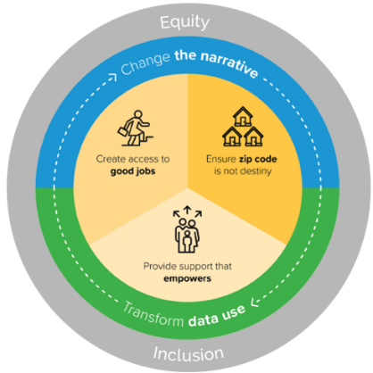

REQUIREMENTS
- The full, consistent participation of 1-2 foundation staff members over the two-year experience
- Content expertise from participating community foundation staff members, as well as their ability to drive strategy within the organization
- A SAL topic-related project already underway or in a stage of readiness for further development and refinement through participation in the Strategy Action Lab

TIME COMMITMENT
- 2-3 in-person. One of the in-person meetings is held adjacent to CFON’s Annual Forum in May of each year.
- 3-4 virtual meetings. Virtual meetings are typically two hours in length and held on Zoom.
- One-on-one coaching sessions. Participating community foundations are encouraged to take advantage of one-hour coaching sessions at least twice to ensure individualized strategy support.

COST
- No registration cost for participating community foundations
- $1,000 stipend provided to help defray travel expenses

STRATEGY ACTION LAB CURRICULUM
The Strategy Action Lab curriculum focuses on a 12-month immersive experience that sharpens strategy development and implementation. The outline below provides a general approach that is adapted and adjusted as the group progresses.
Core Activities | Curriculum
SAL Virtual Meeting: An Introduction to the Process, Goals, and Objectives | Participants are introduced to the Good Strategy framework and discuss and refine the goals and objectives for the SAL cohort. Participants will get a preview of the proposed projects of their peers.
SAL In-Person Convening: Becoming a Student of Good Strategy | The convening will allow participants to become well-versed in the Good Strategy framework and assess their foundation’s current/planned strategy through the Good Strategy Framework and support the development of an initial strategy prototype. Each community foundation will be expected to provide a presentation and discussion on their project/strategy.
SAL Virtual Meeting: Focus on Research and Data | The agenda will include a focus on the research and data informing good strategy.
One-on-One Virtual Coaching Session | The SAL Facilitator/Coach will have individual coaching sessions with each community foundation team to address emerging issues and provide 1:1 consultation to support the project’s development and implementation.
SAL Virtual Meeting: Common Measurement Framework for the SAL Cohort | The SAL Leads will work with the SAL cohort to identify a common measurement framework across the foundations working on the SAL theme. This effort will include ways to bring an equity lens to the work.
One-on-One Virtual Coaching Session | The SAL Facilitator/Coach will have individual coaching sessions with each community foundation team to address emerging issues and provide 1:1 consultation to support the project’s development and implementation.
SAL In-Person Convening: Rapid Prototyping and Problem Solving | The SAL cohort will focus this in-person meeting on rapid prototyping, using one or two examples from the cohort for peer exchange and learning. The meeting will also provide a deeper dive on each foundation’s strategy, leveraging the SAL Good Strategy Framework (see Appendix A).
SAL Virtual Meeting: Capturing Learning and Closing Out the SAL Experience | This virtual meeting is a celebratory close-out of the SAL experience, summarizing the work, learning, and next steps required to fully integrate the strategy into the respective foundations. The SAL cohort may decide to independently continue to meet informally or in “peer pairs” to continue their work.

ADDITIONAL INFORMATION
To learn more about the Strategy Action Labs, contact Amy Daly-Donovan (amy@dalydonovan.com or 206-923-3234).

Appendix A - Strategy Action Lab “Good Strategy” Framework: Guiding Questions

