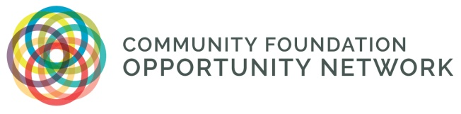

CFON Housing Cohort #2: 2026-27
Purpose:
- Provide an opportunity for a small group of CFON member foundations committed to housing solutions and strategies that align with equity and economic & social mobility goals to convene for learning, sharing, and support.
- Group members will:
  - share their work
  - assess and strengthen their strategies
  - explore innovative approaches
  - provide peer guidance around challenges
  - connect with experts in the field
Process:
- Up to 10 CFON member foundations will participate; these foundations should already have a fairly well thought out strategy, although may be anywhere on the implementation journey.
- The cohort will be facilitated by AJ Herrmann of Accelerator for America, who will manage the process, structure, and activities. AJ facilitated the first cohort and received excellent feedback.
- The group will meet for a 12-month period; virtual meetings will be scheduled every other month for 1.5-2 hours; a day-and-a-half in-person meeting will occur midway through the experience.
- There may be “assignments” in-between meetings to help accelerate learning and test ideas.
- There is no cost to participate, but each participating foundation commits to having 1-2 staff members participate consistently in the scheduled sessions and to fulfill the responsibilities below.
- Participating members are expected to:
  - be prepared to share details of their work (the good, the bad and the ugly!), which requires candor and respect
  - help to identify and/or share resources
  - provide ideas and input to fellow cohort member strategies
  - consider collective action/investment where possible or desirable
  - advocate at the regional and/or national level when appropriate
  - be available to share their experience and learning at the conclusion of the cohort (i.e., webinar for CFON members, panel discussion at Forum, etc.)
- Timeline:
  - Expressions of interest received by August 17, 2025
  - Cohort kick-off in October 2026
  - Cohort conclusion in November 2027
Potential Issues to Explore:
- Philanthropy’s role in a traditionally for-profit space, including tax code implications
- Challenges with partnering with public sector, various involved agencies, national foundations
- Bringing community foundation boards along; identifying and mitigating risk
- Structures for managing fundraising
- Perception of non-partisanship in an uncertain federal landscape
- Data sharing/local data partners to inform the Task Force’s work and for other purposes (fundraising, advocacy, etc.)
- Tapping into other capital beyond financial (social, political, etc.)
- Working with CDFIs, investors, real estate professionals
- Strategies for leaning into policy advocacy work

